Vintage games collector

Copyright 2021 by Jimmy Dahl Pedersen

Content
Purpose: 2
Minimal delivery: 2
NOT included: 2
Homepage 3
lTechnologies used: 4
lPrerequisites: 4
lData 5
lClasses: 5
lManufacturer (of the game) 5
lGame (The game itself) 5
lGamePlatform (the game can run on) 5
lGameType 5
lGrade 5

Purpose:
The purpose of this solution, is a customer to be able to register his/hers
vintage games on the homepage.
This includes creating the manufacturer of the game, creating the platform, the game
can run on (if it does not already exist). What kind of game it is and if the type of game does
not exist, can create it.
When the user creates the game, he/she can also grade the game, register when it was last
played and on what level, if the game has more than 1 level.
The use can also ”drag and drop” an image of the game.

Minimal delivery:
A webpage, where a user can at least create, delete, read and update a game
(including the image), using MCV design.
Some basic lists will be available, such as a list of the registered games.

If time permits, a CRUD for the platform, manufacturer, game type and grade
will also be done.

NOT included:
Identity management will NOT be included, such as user login, log off and registration.

Homepage
This layout will ofcouse be changed to fit my solution!

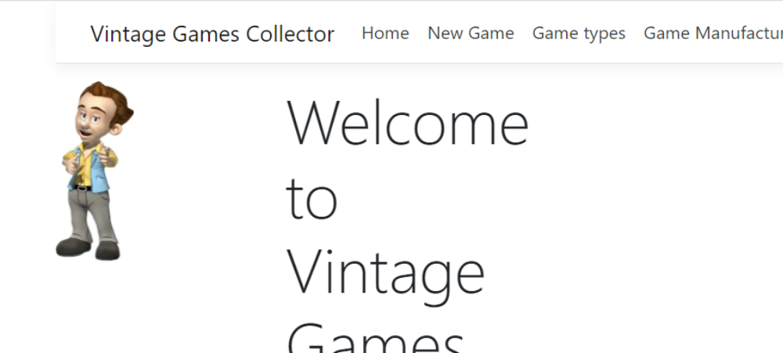

Technologies used:

- Microsoft EntityFramework
- SQLserver
- MVC
- ASP.NET
- Partiel views

Prerequisites:
When the database is created, the following classes will automatically be filled:
Manufacturer
Microids
Sierra
Sid Meier

Grade
1: Superb
2: Good
3:Bad

GameType
Adventure game
First person shooter
Strategy
Worldbuilder

Platform
Windows, 3.1
Windows, XP
Windows, 10
Dos, 7.1

Data

Classes:

Manufacturer (of the game)
Name (of the company)
Url
Year (created)
exist (still existing Y/N)

Game (The game itself)
Name (of the game)
GameType (of the game))
GamePlatform (Windows, Dos etc. )
Grade (How good is it)
Image (of the box/cartridge)
LastPlayed (date)
PlayedLevel

GamePlatform (the game can run on)
Name (of the platform)
Version (of the platform)

GameType
Name (Name of the type, FPS, adventure game etc.)

Grade
Number (Grade number)
GradeText (Grade in text)

